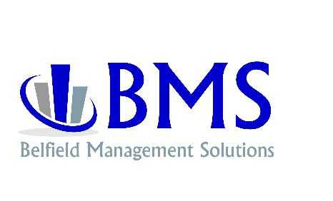
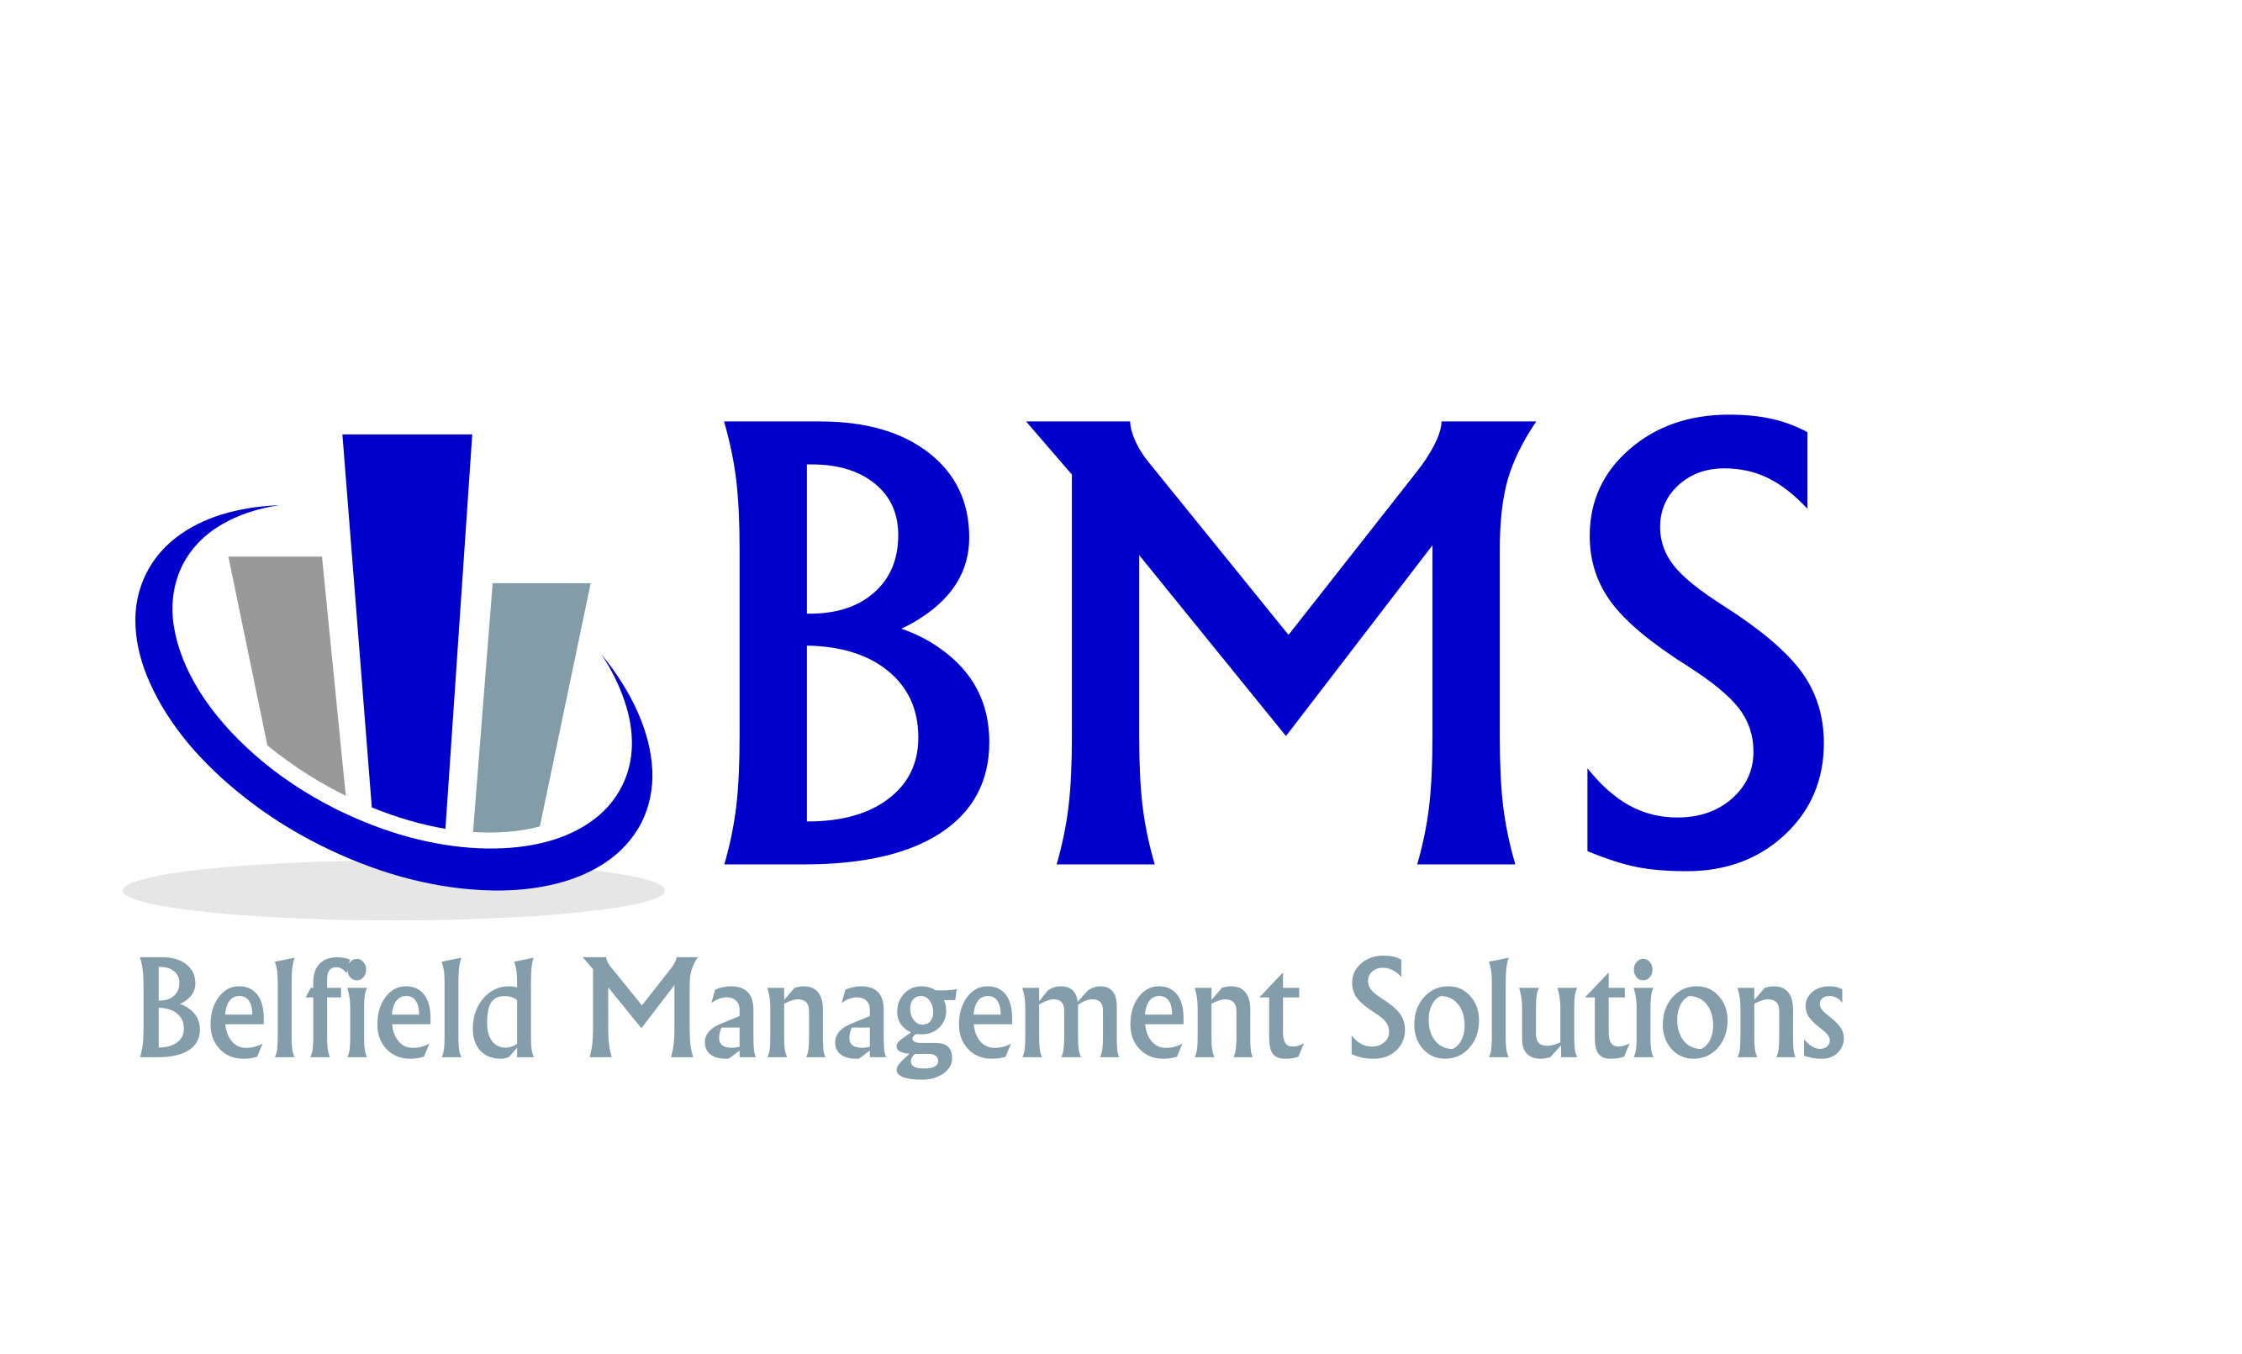


What is BMS Business Analysis

ABMS Analysis is a powerful business tool that helps you maximize your company’s potential. The analysis has been engineered to enhance your organization’s strength... and eliminate your weaknesses. It will enable you
to move your company to the next level of success— increased revenues, reduced costs, more efficient operations, more free time.


The analysis is a thorough, two-day review of your business. We observe how you run your organization. We meet with key personnel. We benchmark your company against the best-managed, most profitable companies in your industry. We research how they address the same issues and concerns that you are facing— what works, and just as importantly, what does not.

Find out more about us What is Business Analysis? Our deliverable— a written, specific plan to accomplish your goals, eliminate problems, and enable you to capitalize on opportunities. Our business analysis is backed by our satisfaction guarantee.
Contact Us:
222 Graham Way
Shelbyville, TN 37160
(615) 869-8220
www.belfieldinc.com

On target business solutions... guaranteed.

Increase Sales Reduce Costs

Improve Cash Flow Enhance Profits

Easier Operation Better Control

Boost Productivity Diversify Markets
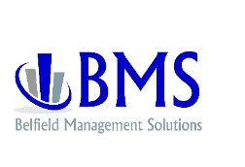
MANAGEMENT
OPER ATIONS
MARKETING
FIN ANCE
C O N T R O L
Planning
Short-term Objectives
Long-term Goals
Company Policies
Profit Planning
Capital Management
Succession Planning
Exit Strategy
Organization
Structure
Accountability
Communications
Production
Facility Layout
Planning & Scheduling
Inventory Management
Process Flow
Quality Control
Productivity
Human Resources
Accountability
Job Descriptions
Performance Evaluation
Discipline
Employee Handbook
Staffing
Compensation
Benefits/Incentives
Control
Information Systems
Accounting
Cost Systems
Reporting
Purchasing
Procedures & Controls
Inspection
General Accounting
System Review
Procedure Analysis
Information Accuracy
Accounting Software
Profit Controls
Expense Controls
Cost Systems
Costing Methods
Cost Control
Cost Analysis
Pricing Methods
Reports
Profit & Loss Statements
Balance Sheet
Management Reports
Budget Variance
Information Systems
Software Packages
Installation
Training
Planning
Short-term Policies
Long-term Policies
Capital Structure
Tax Planning
Budgeting
Funding Strategy
Control
Cash Flow Forecasting
Cash Management
Credit & Collections
Analysis
Financial Ratios
Sales
Organization
Forecasting
Implementation
Training
Accountability
Compensation
Market Analysis
Lead Generation
Technology Integration
Marketing
Market Research
Competitive Analysis
Strategic Planning
Tactical Execution
Marketing Materials
Website
Advertising
Budgeting
Result Measurement

